OR – 538
Final Project

Practical Optimization

Contents
Introduction 3
Data Exploration 4
Skewness and Kurtosis of the Cryptos 6
Crypto QQ Normal Probability Plots 6
Optimization 8
Weight on tangent portfolio and risk-free 12
Constraints 13
Efficient Frontier 13
Weights of the Optimal Portfolio: 13
Value at Risk 14
Portfolio Returns 14
Calculating Value at Risk 14
Early Errors 15
Future work 18
Conclusion 19
How to Run the R-code: 20
References 23

Introduction
The core focus of this project was portfolio optimization and it was conducted on cryptocurrency. The cryptocurrencies data was extracted through an R package called crypto. Initially the data was downloaded for 15 cryptocurrencies that included bitcoin as well. However, for different parts we selected different cryptos for analysis. The date range for data extraction was from October 1, 2016 to October 1, 2019 and again for analysis we had different number rows for different parts. Following are cryptocurrencies that were used for developing efficient frontiers.
Currency | Symbol | Currency | Symbol
Litecoin | LTC | Nxt | NXT
Peercoin | PPC | Auroracoin | AUR
Namecoin | NMC | Dash | DASG
Dogecoin | DOGE | NEO | NEO
GridCoin | GRC | Monero | XMR
Primecoin | XPM | NEM (New Economy Movement) | XEM
XRP | XRP | PotCoin | POT

To work on this project, we used R language and leveraged following R packages/libraries:
- crypto
- quantmod
- corrplot
- quadprog
- ggplot
- ggrepel
- fGarch
- linprog
- Mass
Initially we did some statistical analysis that included identifying the correlations, skewness and kurtosis. After that we visualized and tested the distributions of each crypto. Once we were done with that, we did some optimization developed some efficient frontiers the details of which are shared in the later parts.
After developing efficient frontiers with only a constraint to stop short selling we decided to put some more constraints on our data. We developed another efficient frontier with some constraints. Lastly, we worked on value at risk and identified it which shared in the last part of this report.
Furthermore, we studied some past studies on the same topic and later found that our results of the portfolio are closer to them.
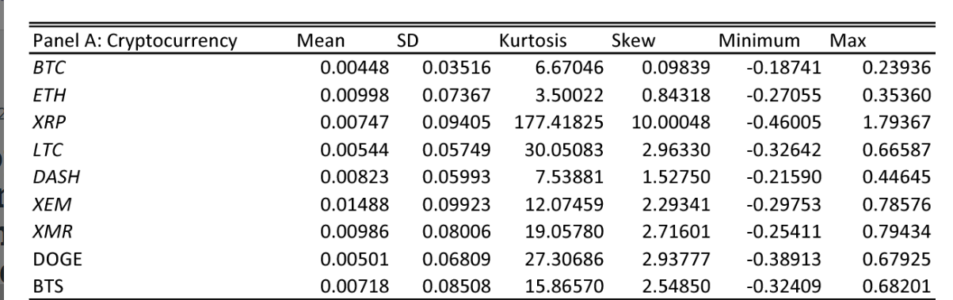(Bjordal & Opdahl, 2017)
The above chart that is taken from one of the past studies that confirms that our daily risk and return are closer to these studies as well. The risk and return on charts are not higher they are just converted into percentages.

Data Exploration
At the initial part of our project we wanted to identify any interesting patterns and know more about cryptos prices and returns before performing further optimization models. We started by calculating the average mean and standard deviation of the returns and prices.
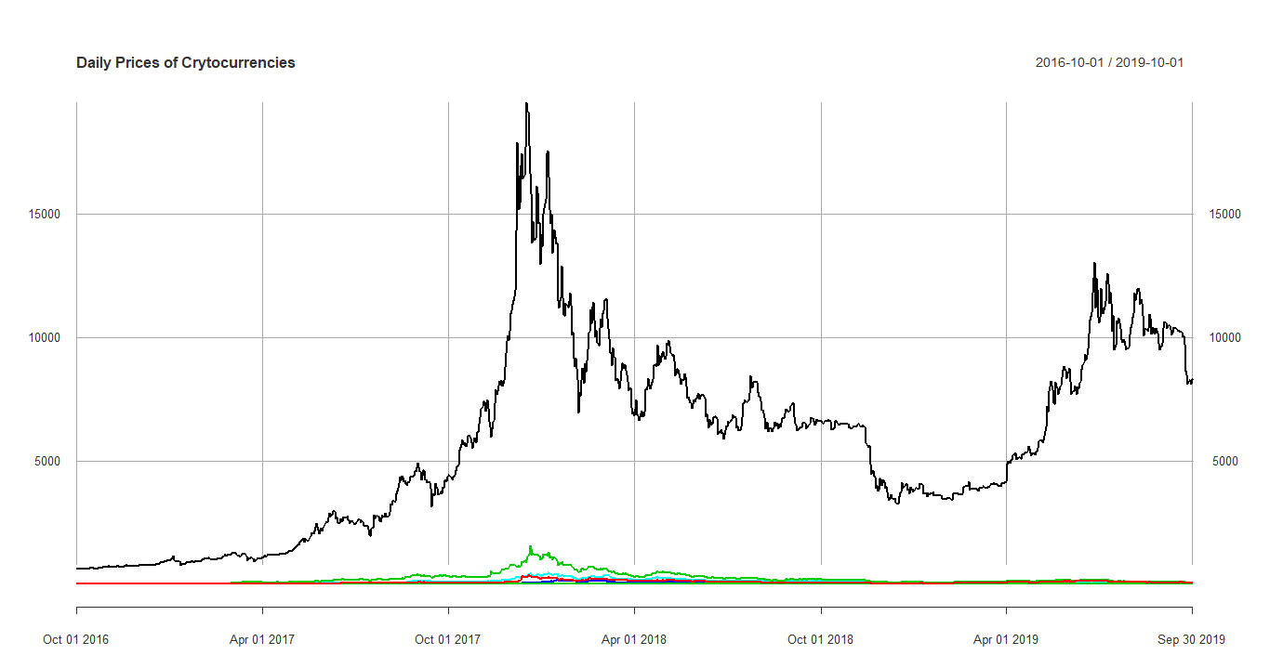

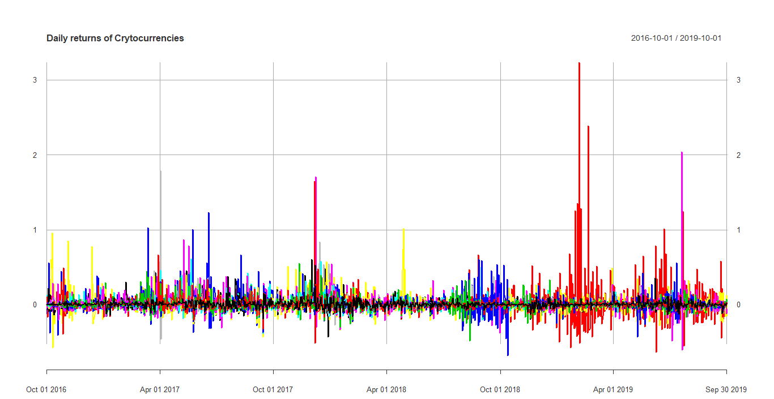

As we can see Bitcoin (Black Line) has significant higher price value than all the other cryptos we assumed that it will have a major weight on our portfolio and thus we got rid of it early on. Further the plot above shows that the returns of the cryptos are stationary as the means are all constant over time.
We used the means and standard deviation to further obtain skewness and kurtosis of the distributions. Skewness and kurtosis help characterize the shape of a probability distribution. Skewness measures the degree of asymmetry, a zero-skewness indicating total symmetry. Positive skewness indicating a relatively long right tail compared to the left tail, and negative skewness indicating the opposite (Ruppert & Matteson, 2015).
Kurtosis shows us the extent to which probability is present in the center and especially the tails of the distribution (Ruppert & Matteson, 2015). It is basically measuring the outliers as or the values that are more than the standardized data, which is raised to the fourth power.

Skewness and Kurtosis of the Cryptos
As we can see the table has the values of skewness and kurtosis of the cryptos. The kurtosis values mentioned in the table are the Excess kurtosis. We can calculate population kurtosis by adding 3 to the Excess kurtosis.
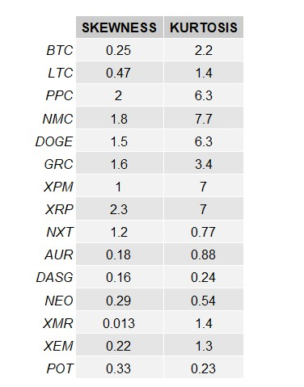

Crypto QQ Normal Probability Plots
Normal probability plots are used to check whether the sample used follows a normal distribution or not. A plot which deviates from the straight line is said to be not normal (Ruppert & Matteson, 2015). We use qqnorm() package in R to compute the following normality plots. While looking at a normal plot with nonlinear pattern it is essential to understand which axis contains the data. For the following graphs the x-axis contains theoretical quantile and y-axis contains the data. A reference line is plotted through the quantiles to check if the plots are reasonably linear or not.
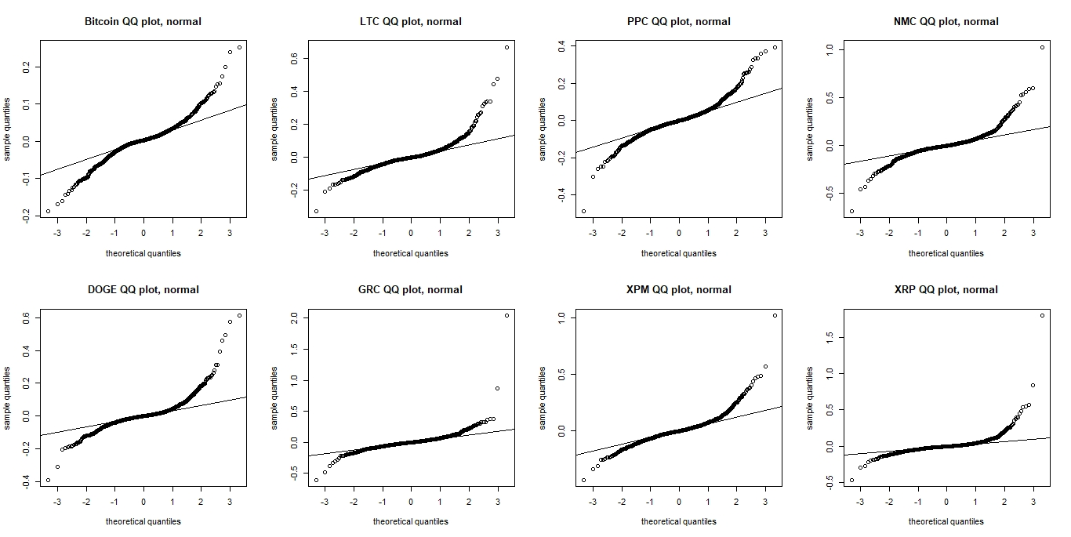

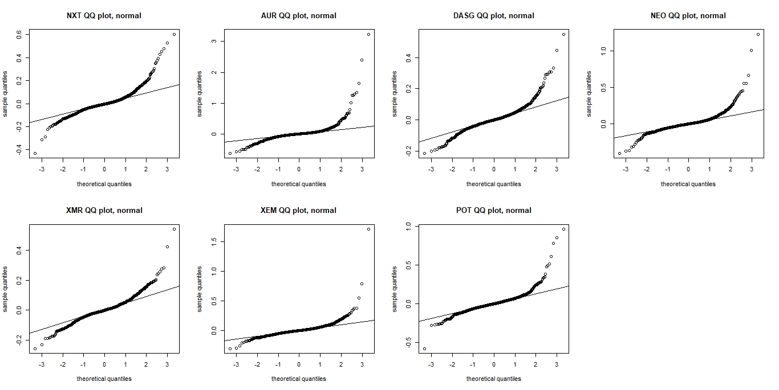

Optimization
Once we finalized our cryptos the next phase was to develop an efficient frontier for the portfolio. The data in the first phase contains 14 cryptocurrencies and for the period of 245 trading days that ends October 01, 2019. After that we tried to develop few more efficient curves to see how the results changed. Further we identified the tangent portfolio and MVP and then tried to see how much we should invest in the risk-free and how much in the tangent portfolio. For the risk-free rate we extracted the information from “treasury.gov” and hardcoded that value in our R code.
Now we will share about our first efficient frontier and following is the plot we achieved:
NOTE: Both axes shows the result in percentages
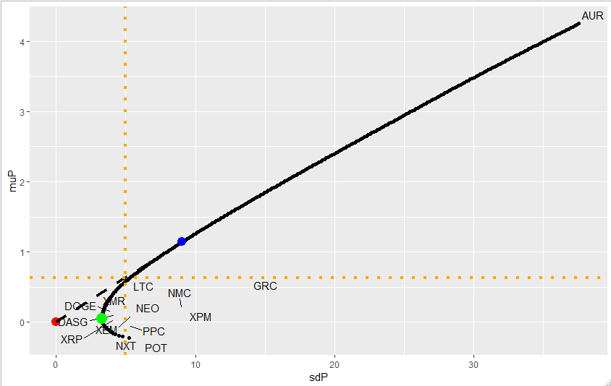
The green dot on the plot represents MVP, the blue dot represents the tangent portfolio and the red is the risk-free rate. The x-axis and y-axis represent the numbers in percentages.
The above plot shows the risk and the returns on the portfolio that we will built using the 14 cryptos about which we shared earlier. The returns and risks are in percentages as we shared earlier so our tangent portfolio seems to have somewhere around 1.2% daily return with around 8 to 9 % risk. This is not something that seems implausible because as we read some earlier studies about cryptos and it was found that average daily return was more than 2.5%. This makes our portfolio reasonably well as that study included more than 222 cryptos involved (Guest, 2018). As we are done with the basic understanding of our tangent portfolio, we will now look for weight on the tangent portfolio. Keep note that at this point we are not allowing any short selling.
On the tangent portfolio following will be weights:
Crypto | Weight | Crypto | Weight
LTC | 5.61e-01 | NXT | 2.51e-16
PPC | -1.29e-17 | AUR | 1.96e-01
NMC | -5.43e-19 | DASG | 5.93e-17
DOGE | 1.32e-01 | NEO | 3.59e-16
GRC | 1.12e-01 | XMR | 7.57e-19
XPM | 0.0e+00 | XEM | 3.42e-17
XRP | -2.55e-16 | POT | -5.69e-17

The weights highlighted orange shows that they have the major chunks of the portfolio and the rest are negligible. We didn’t allow short selling, yet you see some weights with negative signs, but they are also so small that they are almost equivalent to zero. Thus, our tangent portfolio contains most of its part in LTC, DOGE, GRC and AUR.
The next thing we did was to identify the return on a five percent risk. For that we drew an orange dotted vertical line and checked where it cuts the line between risk free and the tangent portfolio. To identify that point we used the lm() function and the answer we got is 0.633%. This means on five percent risk the daily return would be 0.633%. The allocations of weight between risk free and the tangent portfolio will be discussed with one of the efficient frontiers later in this paper.
Furthermore, we tried to see what the risk would be if we want at least one percent return. Again we used the lm() function for the calculation. Now we first drew a horizontal orange dotted line at y = 1 and then calculated where it cuts the line between tangent portfolio and risk-free rate and we found that on 1% daily return the risk would be almost 8.499%. The plot below illustrates what we just mentioned:
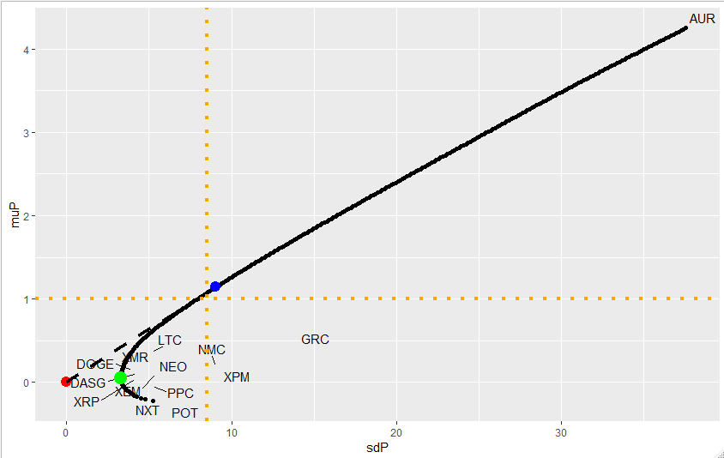
As you can see AUR was quite far away from the rest of the cryptos so we decided to check the behavior of our portfolio means how our portfolio will look like without the presence of AUR. The following plot was achieved without AUR:
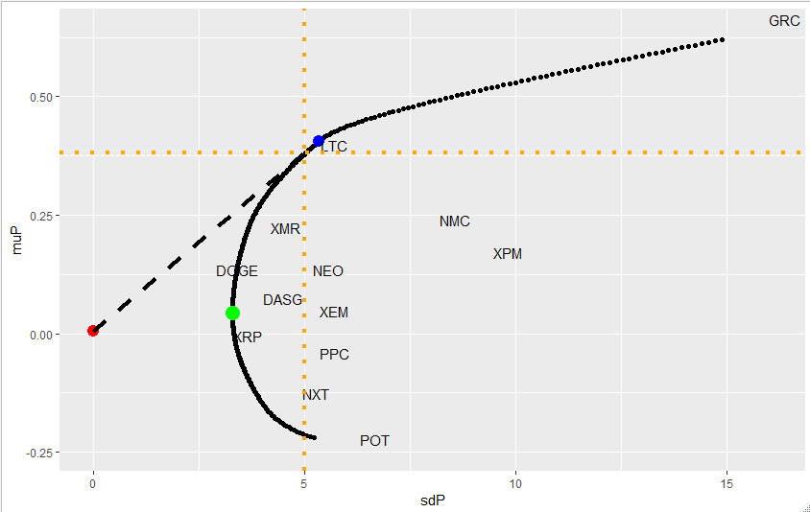

Following are weights for the new portfolio that don’t have AUR now:
Crypto | Weight | Crypto | Weight
LTC | 8.67e-01 | NXT | 4.78e-16
PPC | 1.76e-16
NMC | -2.71e-19 | DASG | -1.95e-16
DOGE | 9.16e-03 | NEO | 1.47e-17
GRC | 1.24e-01 | XMR | -1.05e-17
XPM | -9.19e-19 | XEM | -5.37e-18
XRP | -2.63e-16 | POT | -1.56e-17

The above plot is significantly different from the previous one as the overall risk is somewhere around 5.5% with 0.39 or 0.4% daily return which is quite lower compared to 1.2 that we had for the previous one. As we just used no short selling constrain up till this point so most of them had weights to zero with most of the part in two cryptos that includes LTC and GRC. Further if you see in this portfolio for the same risk that is 5% the return is quite low which 0.381% which almost 40% less compared to previous portfolio developed with AUR.
Lastly, this part was just for analysis not an actual portfolio that will be used in later part for VaR (Value at Risk) as we just wanted to see if we remove a high-risk high return crypto from our data how it would impact our overall portfolio.
As we were working on VaR we ran into some issues that will be discussed later in this paper. During analyzing the issue, we generated another efficient frontier with more data points. This time we included the data for three years that are more than 1000 days. The following is the plot we achieved:
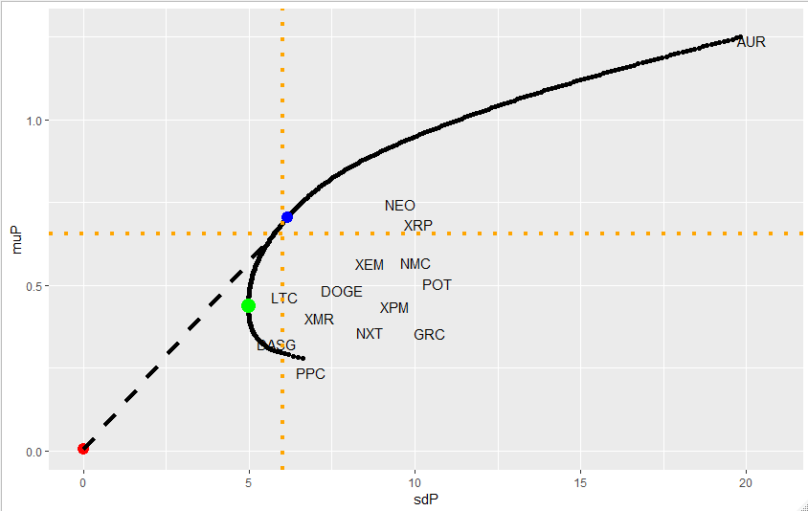
We will not go in much detail about this plot as we figured out our initial issue and we believe the efficient frontier we developed in the first phase with 245 days is good enough for our further analysis as we worked on constraints and value at risk. Thus, this new portfolio was discarded from further analysis as we know 3 years data doesn’t make much sense in portfolio optimization. But it was important to share it here at this point because it will be relevant when we will discuss the issue we faced in VaR part.

Weight on tangent portfolio and risk-free
We calculated weights for the risk-free and tangent portfolio through the following formula.
Formula: W = (μr - μf) / (μm - μf)
μ_{r} = 1
μ_{f} = 0.005
μ_{m} = 1.14
Tangent Portfolio = 0.877
Risk-free = 0.123
The weights are based on the return that we need which is one percent.

Constraints
After obtaining the efficient frontier and weights of the optimal portfolio in the previous section we wanted our next step to be able to constrain our weights in a range. At first, we decided that we will allow short selling, thus the range was set from -10% to 40%. Since we were going to place constraints on w (weight of the portfolios) we used linear programming to find the set of feasible expected portfolio returns. We use the function SolveLP() twice, once to find the smallest possible portfolio return and another to find the largest expected portfolio return.
So, the range that we used for 300 possible target values that were used are [-0.785345, 2.23869].

Efficient Frontier
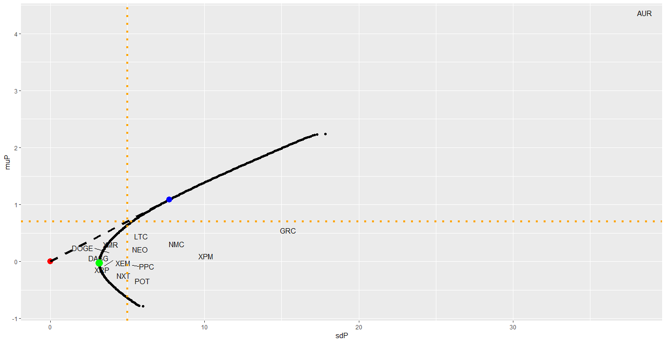

Weights of the Optimal Portfolio:
Crypto | Weight | Crypto | Weight
LTC | 0.40 | NXT | -0.10
PPC | -0.10 | AUR | 0.15
NMC | 0.08 | DASG | -0.10
DOGE | 0.40 | NEO | -0.10
GRC | 0.12 | XMR | 0.40
XPM | 0.08 | XEM | -0.045
XRP | -0.10 | POT | -0.10

The green shades on the upper table signifies the cryptos that are short selling in our new portfolio.

Value at Risk

Portfolio Returns
With the weighting done by the standard optimization, the returns of the portfolio were calculated via the weighted-average return. These returns follow this distribution:
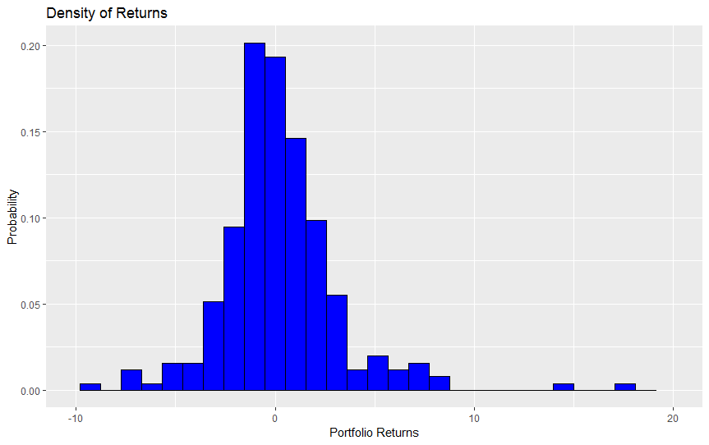
There are some extreme positive returns and some less extreme negative returns. While it may not be a perfect t-distribution, it approximates it.

Calculating Value at Risk
While the efficient frontier shows the trade-off between risk and return, the value at risk allows for an easier visualization of how much capital is at risk. In order to retrieve this value, a t distribution is fit onto the portfolio returns. Using the learned parameters and a confidence level, the amount of money that could be lost at 1 – α probability can be determined. Alternatively, the VaR can be determined by using the α quantile of the sample returns distribution. Both methods were used for completeness. The portfolio value is $1,000,000.

Early Errors
When the analysis was done the first time, the portfolio returns data structure was in percentage terms instead of actual. This meant that the VaR was off by a factor of 100. The first result is shown below:
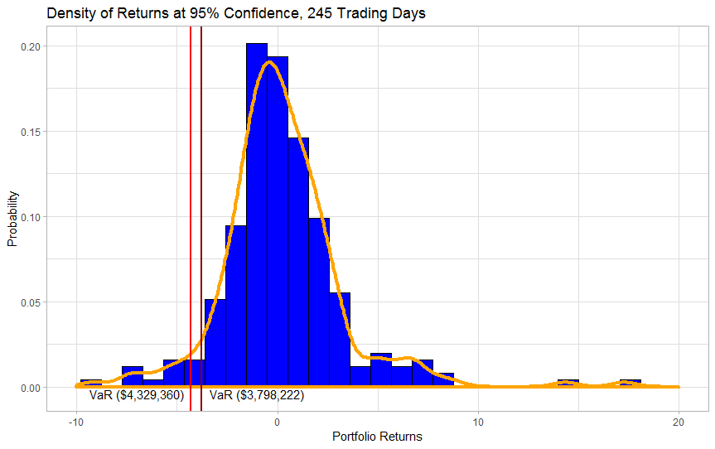
Where the darker red line is the nonparametric VaR and the lighter line is the parametric estimate. The VaR in both cases is substantially above the value of the portfolio. This is obviously an issue. Attempting to find a value that makes sense, the confidence level was continually decreased until the value was less than the total portfolio value.
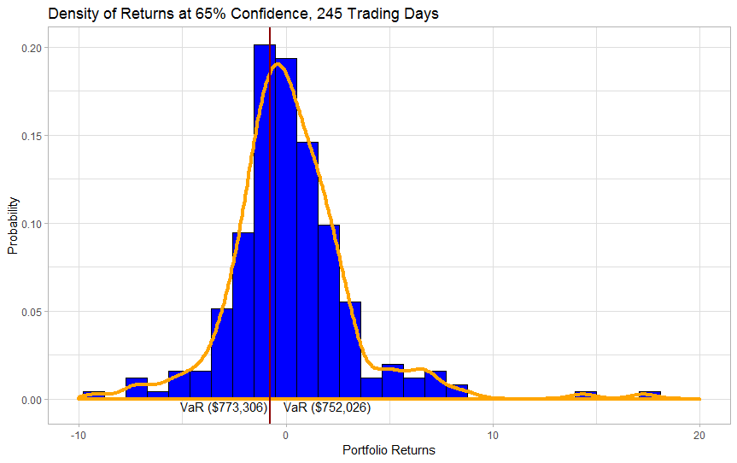
Eventually, a 65% confidence level was the first to get a viable solution. This level of confidence is of no use to anyone.
Not fully understanding the issue, more data was used to try to make the calculation work. With 1,000 days of trading and a new portfolio composition, this is the result:
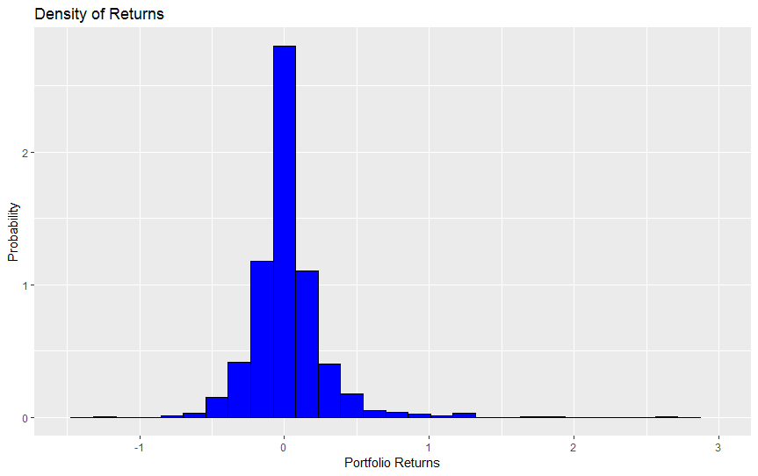
With more data, the returns experienced less variation. The VaR estimates were:
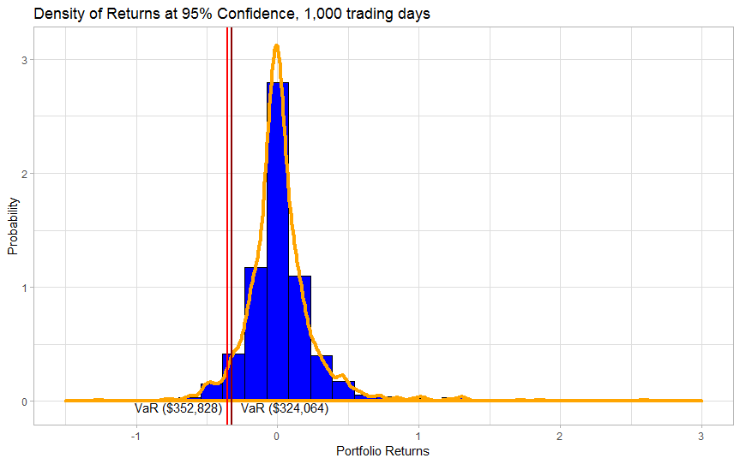
Here, the VaR is within the portfolio value without sacrificing a usable confidence level. Still, using 1,000 trading days is too many and too much out of data information is being used.
Finally, the issue of the returns data structure scale was figured out and the analysis was run again on 245 trading days.
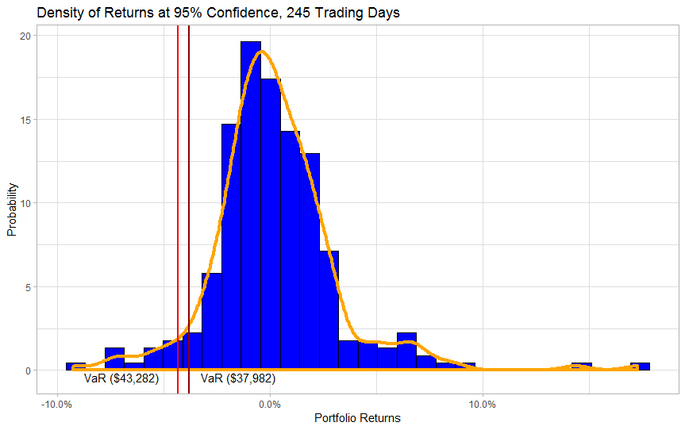
At last, the correct VaR is calculated. The nonparametric method shows a smaller VaR, likely because of the right skew. With a $1,000,000 portfolio, either 4.3282% or 3.7982% of its value is at risk in one trading day.

Future work
There are many other things that could be shown in regard to Value at Risk. Firstly, the time frame of the VaR could be increased from one day to N-days. This information will show how much can be lost over a specific time-horizon. Another thing that could be done is to parametrically fit the returns with a different distribution, such as log-normal or exponential. Given that returns are positively skewed, the impact of this analysis is not as important because risk is concerned with downward sections of the distribution. Finally, a bootstrap sampling method could be used to take a smaller, more recent, sample and create a large sample to fit the distribution on.

Conclusion
There are some limited studies on the topic of cryptocurrencies and usually, the portfolio optimization is done for stocks, but we decided to do something different and exciting thus we decided to work on optimizing a portfolio based on cryptocurrencies for our final project. While working on this project we found that risks with cryptos are comparatively higher compared to a portfolio based on stocks, but the returns are also higher. This was not something for us that we didn’t expect. As far as this project goes, we believe that we were able to get the basic idea of the behavior of cryptos over time and how much risk is involved in investing in cryptos. Lastly, I think this project can act as a benchmark for us if we decide to do some future research on cryptos.

How to Run the R-code:
- In this part refer to file named “OR-538_Project_FINAL.” The first step is you load the libraries and packages so run the following lines first:
FROM | TO
14 | 19
If there is an error while running this line this may be because you may not have the packages installed. Thus, refer to following lines and run only those lines for which you don’t have the package installed.
FROM | TO
4 | 9

- After installing the libraries kindly ignore next few lines and you don’t need to run them as we are providing you the dataset and you don’t need to extract on runtime. At this point refer to following line numbers and set the path1 and path2 variables to the location where you have the data files:
FROM | TO
170 | 171

- After that run the following line to extract data and to create timeseries:
FROM | TO
181 | 188

- If you want to visualize the correlation plot you run the following lines of code:
FROM | TO
209 | 211

- The following line of code will generate the first efficient frontier curve with data based on 245 days. The plot will also visualize what will be the return if someone is willing to take 5% risk.
FROM | TO
229 | 366

The above line code will generate two plots the kindly refer to the second plot as it is clearer visually.

- The following line of code will generate the second efficient frontier curve with data based on 245 days and without the crypto named AUR. The plot will also visualize what will be the return if someone is willing to take 5% risk.
FROM | TO
385 | 522

The above line code will generate two plots the kindly refer to the second plot as it is clearer visually.

- The following line of code will generate the first efficient frontier curve with data based on 245 days. The plot will also visualize what will be the return if someone wants 1% return.
FROM | TO
539 | 679

The above line code will generate two plots the kindly refer to the second plot as it is clearer visually.

- The following line of code will generate the first efficient frontier curve with data based on 3 year. This was specifically generated because we had some issues with VaR but as we have catered that issue it is no more required. However, if you still want to run it following are the lines of code you may need to run.
FROM | TO
697 | 837

- For Skewness and Kurtosis refer file name “cryptoexploration” and set path3 and path4 variables to the location where you stored the data file we shared. Following are lines for path variables.
FROM | TO
4 | 5

- In continuation with previous part you can run the following line of codes that will generate all the plot. However, if you want to run each part separately, they are marked within the R-file and you can do that as well.
FROM | TO
7 | 369

- For the constraints part where we created a portfolio by allowing short-selling yoy refert to file name “constraints”. Run the libraries if you don’t have otherwise set the path3 and path4 variables to the location where you stored the data file we shared. Following are the lines for parth3 and path4
FROM | TO
11 | 12

- Run the following lines of code to optimize a new portfolio based on the constraints we shared earlier. *
FROM | TO
15 | 208

- In this part again refer to file named “OR-538_Project_FINAL.” The following lines of code will calculate and plot VaR graph.
FROM | TO
858 | 1008

We have two other files which contain some part of VaR which contains some of our more analysis on the topic. However, this analysis was conducted as we were getting some issues initially thus it’s not the part of our final code, but we have attached both files as supportive files for your reference. The names of files are following:
- OR-538_Project_VaR_Support1
- OR-538_Project_VaR_Support2

*the code runs fine but on a separate pc we had some issues running the same line code.

References
Bjordal, A., & Opdahl, E. (2017). paper/Portfolio-optimization-in-the-cryptocurrency-market-Bjordal-Opdahl/de21912b499ea9f11fbecb87d455a22c068eebdf/figure/1. Retrieved from semanticscholar: https://www.semanticscholar.org/paper/Portfolio-optimization-in-the-cryptocurrency-market-Bjordal-Opdahl/de21912b499ea9f11fbecb87d455a22c068eebdf/figure/1
Guest, G. (2018, Nov 21). news/2018-11-cryptocurrencies-high-volatility.html. Retrieved from phys: https://phys.org/news/2018-11-cryptocurrencies-high-volatility.html
Ruppert, D., & Matteson, D. (2015). Statistics and Data Analysis for Financial Engineering with R examples. New York: Springer.

